RESEARCH MANUSCRIPT SUBMISSION TEMPLATE

Article Category
Specify the nature of the manuscript:
Original Research / Review Paper / Case Study / Conceptual Paper / Short Communication

TITLE OF THE PAPER (ENGLISH – Mandatory)
(Font: 14 pt, Times New Roman / Cambria, Bold, Center Aligned)
शोध-पत्र का शीर्षक (हिंदी – Optional)
(Font: 16 pt, Unicode/ Kruti Dev 010, Bold, Center Aligned)
Subtitle (If Applicable)
(Font: 12 pt, Italic, Center)

Author Information
(Font: 11 pt, Times New Roman / Cambria)
Corresponding Author must be marked with (*)
Author Details (Left Aligned)
First Name:
Middle Name (if any):
Last Name:
Designation:
Department:
Institution / University Name:
City, State, Country:
Email Address:
Contact No. (WhatsApp/ Call):
ORCID ID (if available – 16 digit identifier):
(it’s free you can create from link : https://orcid.org/)

ABSTRACT (English – Mandatory)
(Font: 11 pt, Times New Roman / Cambria, Justified)
The abstract should clearly present the purpose of the study, research design, methodology, key findings, and major conclusions. It must be written in a single paragraph and should not exceed 250 words. Avoid citations, abbreviations, or references within the abstract.

सारांश (Hindi – Optional)
(Font: 12 pt, Kruti Dev 010)
हिंदी सारांश में शोध का उद्देश्य, पद्धति, प्रमुख निष्कर्ष और परिणाम संक्षेप में प्रस्तुत किए जाने चाहिए। शब्द सीमा 200–250 शब्दों तक हो सकती है।

Keywords (English – Mandatory)
(Font: 11 pt)
Provide at least three (3) and not more than six (6) keywords relevant to the study. Separate them with commas.
Example:
Keywords: Gender Studies, Rural Development, Social Change

मुख्य शब्द (Hindi – Optional)
(Font: 12 pt, Kruti Dev 010)
कम से कम तीन मुख्य शब्द लिखें।

MANUSCRIPT FORMAT
The manuscript may be written either in English or Hindi.
Font Guidelines:
• English text: 11 pt Times New Roman / Cambria
• Hindi text: 12 pt Kruti Dev 010
• Line spacing: 1.5
• Margins: 1 inch on all sides
• Page numbers: Bottom center or top right

STRUCTURE OF THE PAPER

1. INTRODUCTION
(Heading Level 1 – Bold, 12 pt)
Introduce the background of the research problem. Clearly state the objectives, scope, and significance of the study. Provide brief contextual literature support where necessary.

2. REVIEW OF LITERATURE
(Heading Level 1 – Bold)
Summarize previous research related to the topic. Identify gaps in existing literature and justify the need for the present study.

3. RESEARCH METHODOLOGY
(Heading Level 1 – Bold)
Describe:
• Research design
• Sampling technique
• Data collection methods
• Tools and instruments
• Analytical framework
Equations, if any, should be numbered on the right side.
Example:
Y = a + bX ........................................ (1)

4. RESULTS AND ANALYSIS
(Heading Level 1 – Bold)
Present findings systematically. Use tables and figures where appropriate. Interpret the results logically.

5. DISCUSSION
(Heading Level 1 – Bold)
Compare findings with previous studies. Explain implications and theoretical contributions.

6. CONCLUSION
(Heading Level 1 – Bold)
Summarize key findings. Mention limitations and suggest areas for future research.

7. ACKNOWLEDGEMENT (If Applicable)
Recognize individuals or institutions that supported the research but are not listed as authors. Mention funding sources clearly.

8. APPENDICES (If Required)
Additional supporting material such as:
• Questionnaires
• Survey tools
• Interview schedules
• Raw data summaries
• Supplementary charts
Label each appendix clearly as:
APPENDIX A
APPENDIX B

REFERENCES
(Font: 11 pt, Times New Roman / Cambria)
All references must follow APA 7th Edition style.
All references used for the study should be cited in accordance with APA style https://apastyle.apa.org/style-grammar-guidelines/references/examples.
In-text citation example:
(Smith, 2020)
or
[1] (if journal uses numbering system)
Ensure:
• Alphabetical order
• Hanging indent (0.5 inch)
• DOI included where available

SAMPLE REFERENCE FORMAT (APA 7)
Some examples of APA style citation given below, more examples can be find on above link.

- Journal Article References
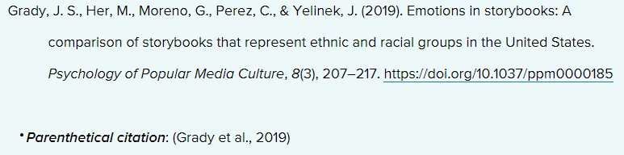

- Book/Ebook References


- Webpage on a Website References
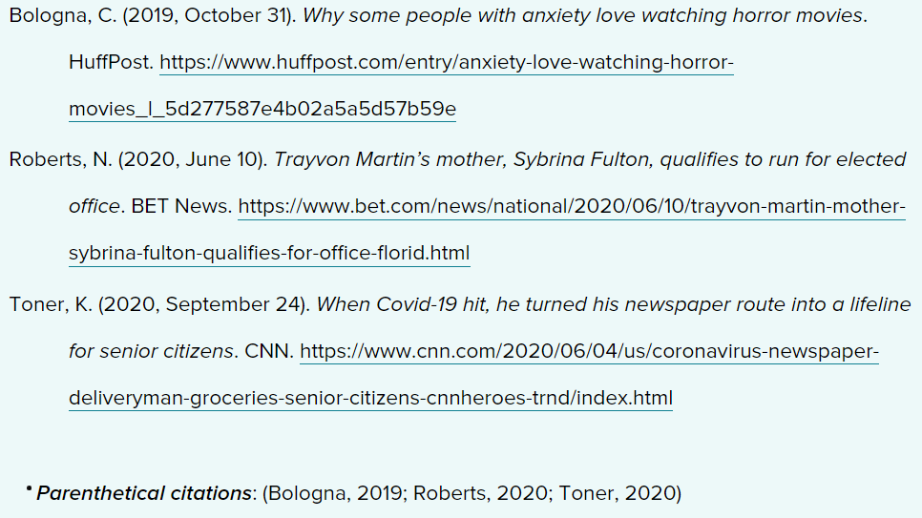
- Wikipedia Entry References
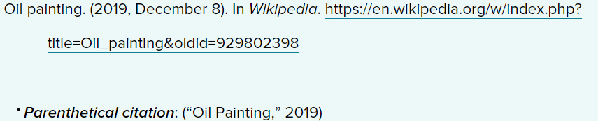

- Conference Proceeding References
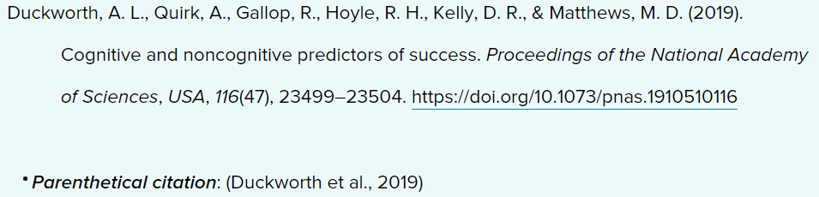
- Chapter in an Edited Book/Ebook References


- Blog Post and Blog Comment References
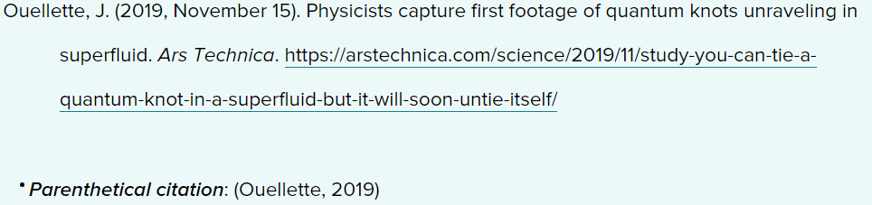

- Newspaper Article References
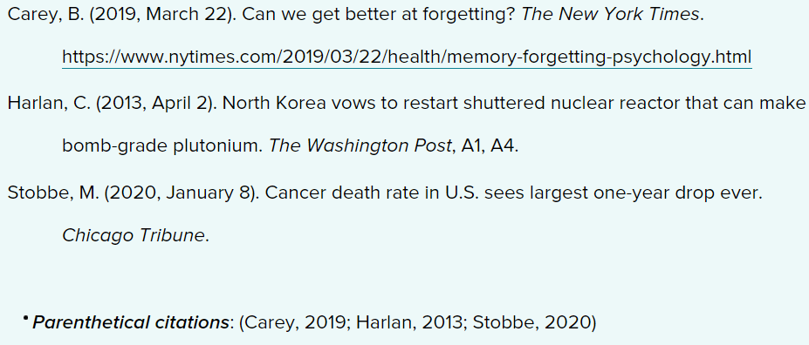

- Artwork References
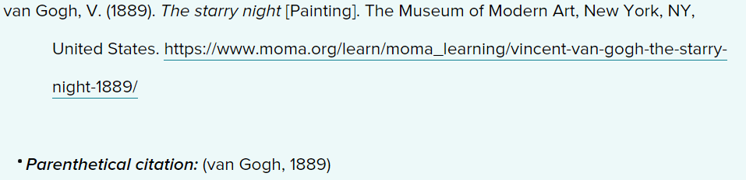

- Film and Television References


TABLE AND FIGURE GUIDELINES
Tables
• Use tables for structured numerical data
• Provide table number and title above the table
• Avoid vertical lines
• Keep format clean and consistent
Example:
Table 1
Distribution of Respondents by Age Group

Figures
• Figures include graphs, charts, images, diagrams
• Figure number and caption must appear below the figure
• Ensure clarity and readability
Example:
Figure 1. Growth trend of literacy rate.

ETHICAL DECLARATION
Authors must confirm:
• The manuscript is original
• It has not been published elsewhere
• Proper citations are provided
• No plagiarism or AI-generated content misuse is involved

FINAL CHECKLIST BEFORE SUBMISSION
✓ Title formatting correct
✓ Abstract within word limit
✓ Keywords provided
✓ APA references verified
✓ Tables/Figures numbered correctly
✓ Author details complete

